Works Cited Page

**DIRECTIONS:** You are required to complete research and include an annotated Works Cited page within your product. If you use it, you must cite it!

Reminder: You must use only credible sources.

STEP 1: As you conduct your research, make sure you keep track of your sources so that you can include them on your Works Cited page. Do this by creating index cards for each source or placing the information into easybib.com as you go. Be sure you record the date of access.

STEP 2: Use easybib.com to create your annotated Works Cited page. Use MLA.

**If you don’t have an account, create one now! This will allow you to log-in and log-out and all work will be saved.

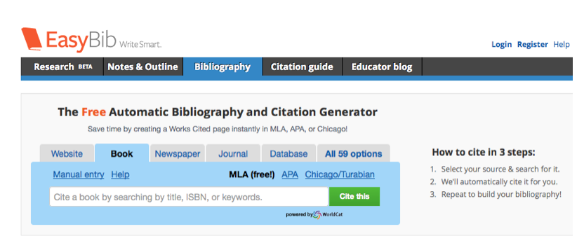

1. Check over all the information that is provided once you “Cite This.” Can any of it be located within the website? If so, add.
2. Click “Add Annotation” and explain how you used this source within your product.
3. Once finished with all of your sources, select them all and Export: Save to GoogleDocs or Print as WordDoc if you are not using a ChromeBook.
4. Check over your Works Cited page to make sure it is formatted correctly

*The page should be titled “Works Cited” (no quotes though) in the center, top line of the page.

*Entries in alphabetical order by the first word of the entry.

*Check MLA format in listing each reference. Be certain that every comma, period, and space is correct!

*The entire page should be double-spaced.

*Indent all lines AFTER the first line of each entry by clicking TAB. This is called hanging indentation.

*Each entry ends with a period.

**Example of a Works Cited page**:

Works Cited

"Black Belt Wiki." *Tessen (War Fans)*. N.p., n.d. Web. 9 Jan. 2015. <http://www.blackbeltwiki.com/tessen>. I used this website to learn more details about the tessen.

"The Katana." *Samurai Swords*. N.p., 2005. Web. 11 Jan. 2015. <http://www.angelfire.com/dragon/swords/katana.html>. I used this website to obtain information about the swords.

"Medieval Japanese Weapons." *Medieval Japan*. N.p., n.d. Web. 4 Jan. 2015. <http://cernyboy.weebly.com/medieval-japanese-weapons.html>. I used this website to look at pictures and to get basic definitions of the different weapons.

"Samurai - Japanese Warriors." *Japan Guide*. N.p., 2015. Web. 11 Jan. 2015. <http://www.japan-guide.com/e/e2127.html>. I used this website to learn about the history of the Japanese samurai.

"Weaponry: Samurai Sword." *History Net Where History Comes Alive World US History Online Weaponry Samurai Sword Comments*. N.p., n.d. Web. 9 Jan. 2015. <http://www.historynet.com/weaponry-samurai-sword.htm>. I used this website to learn about all three weapons.